Comp 421 - Project 3

# Relational Schema

Stadiums(sname, location, capacity)

Matches(matchId, mdate, mtime, duration, round, sname, team1, team2)

sname foreign key referencing Stadiums

team1 foreign key referencing Teams

team2 foreign key referencing Teams

sname NOT NULL

team1 NOT NULL

team2 NOT NULL

Teams(country, national association, group, url)

Players(playerId, dob, name, number, position, country)

country foreign key referencing Teams

country NOT NULL

PlaysIn(playerId, matchId, inTime, outTime, yellowCard, redCard, position)

playerId foreign key referencing Players

matchId foreign key referencing Matches

playerId NOT NULL

matchId NOT NULL

Coaches(coachId, dob, name, role, country)

country foreign key referencing Teams

country NOT NULL

Referees(refId, experience, name, role)

Oversees(refId, matchId)   
 refId foreign key referencing Referees

matchId foreign key referencing Matches

refId NOT NULL

matchId NOT NULL

Goals(matchId, occurrence, minute, penalty, playerId, country)

playerId foreign key referencing Players

matchId foreign key referencing Matches

country foreign key referencing Teams

playerId NOT NULL

matchId NOT NULL

Seats(seatNumber, stadiumName)

stadiumName foreign key referencing Stadiums

stadiumName NOT NULL

Tickets(ticketId, matchId, seatNumber, sold)

matchId foreign key referencing Matches

seatNumber foreign key referencing Seats

matchId NOT NULL

seatNumber NOT NULL

Customers(emailAddress, firstName, lastName, address, password)

CreditCards(number, billingAddress, nameOnCard, cvc, expiryDate, emailAddress)

emailAddress foreign key referencing Customers

emailAddress NOT NULL

Purchased(emailAddress, ticketId, price)

emailAddress foreign key referencing Customers

ticketId foreign key referencing Tickets

emailAddress NOT NULL

ticketId NOT NULL

TeamPlays(matchId, country)

matchId foreign key referencing Matches

country foreign key referencing Teams

matchId NOT NULL

country NOT NULL

# Application Interaction

**Note**: Throughout our project we have used country abbreviations for country names. E.g. Canada = CAN, United States = USA etc.

* 1. 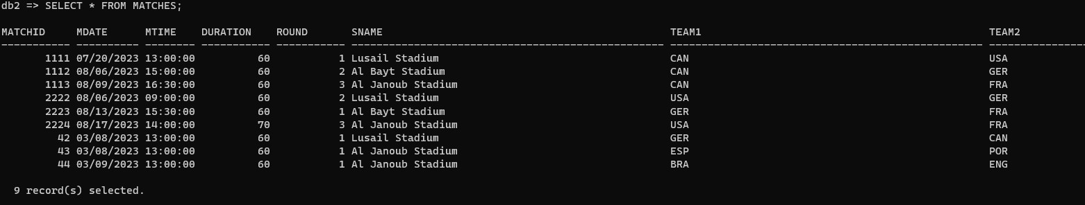
  2. iii)

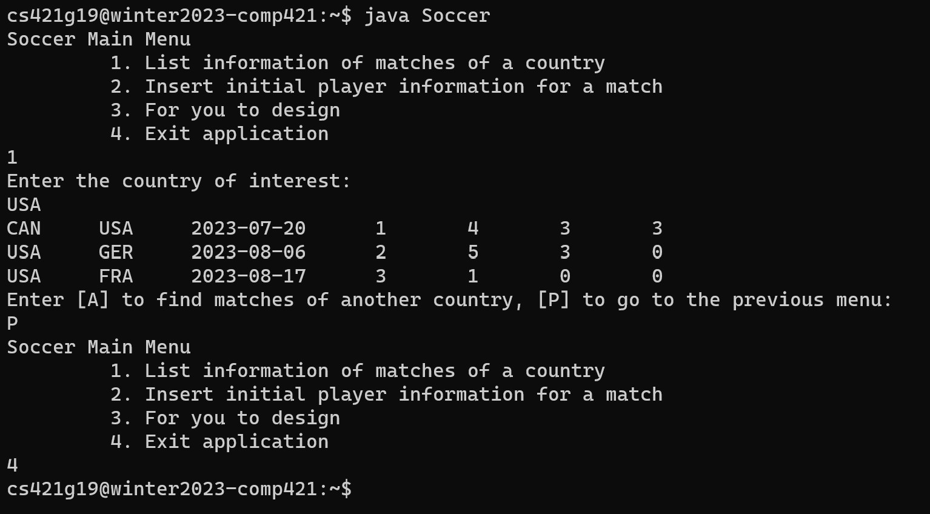

* 1. 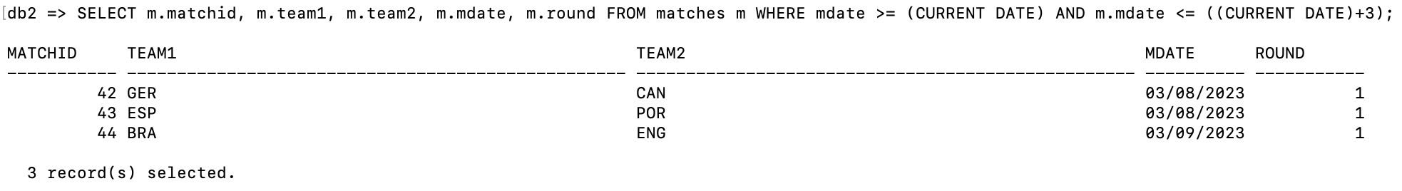
  2. 
  3. 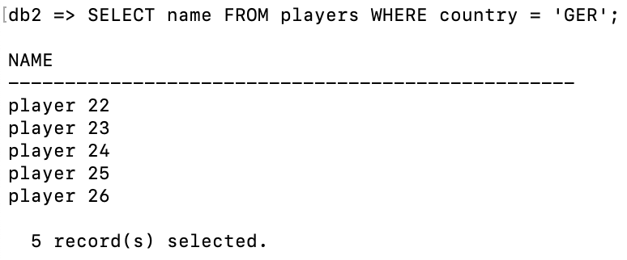
  4. v) vi) vii)

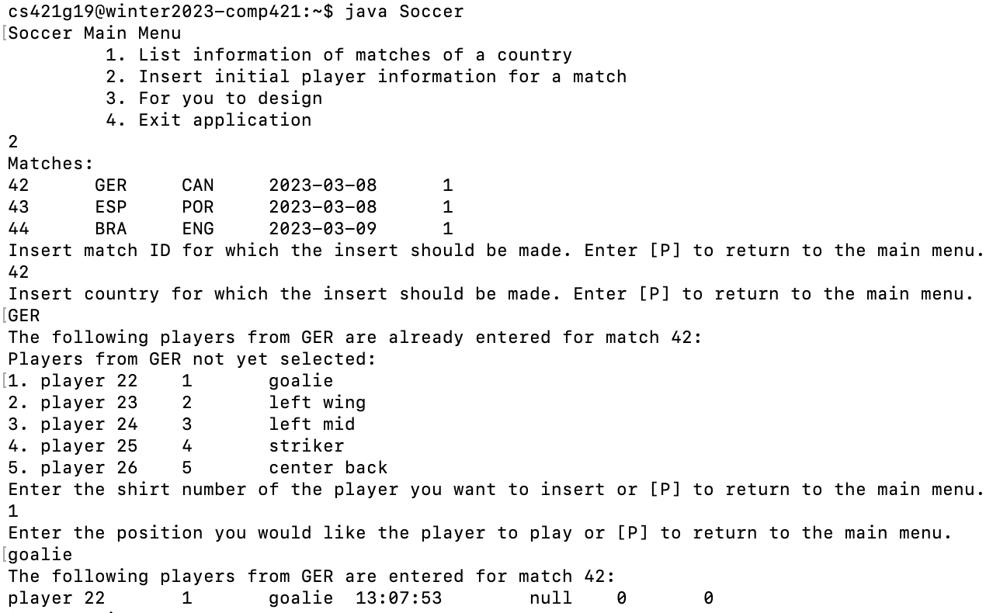

* 1. ix)

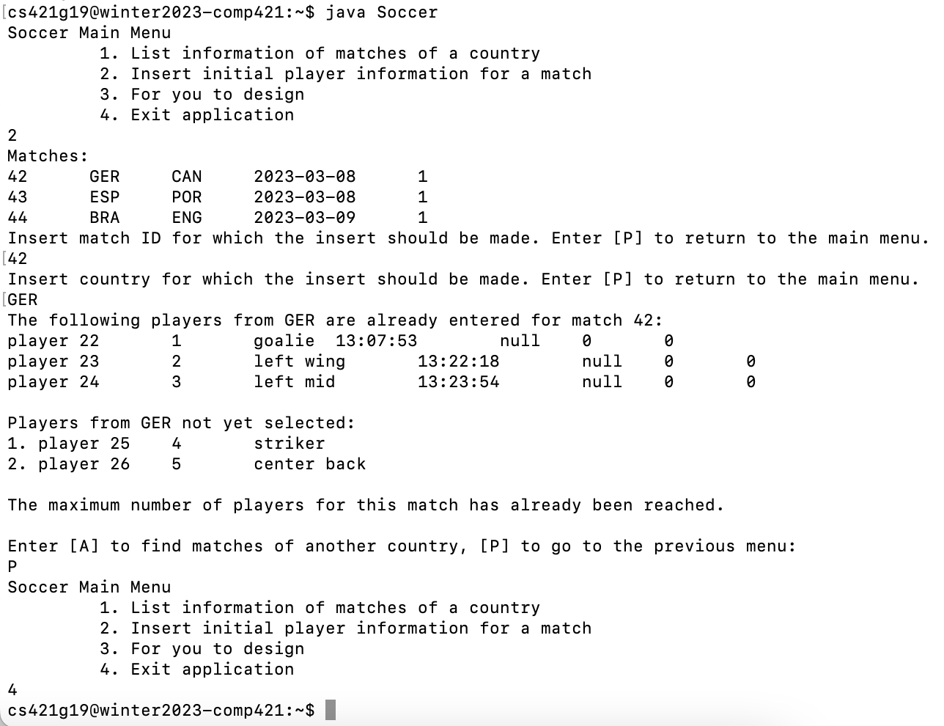

* 1. 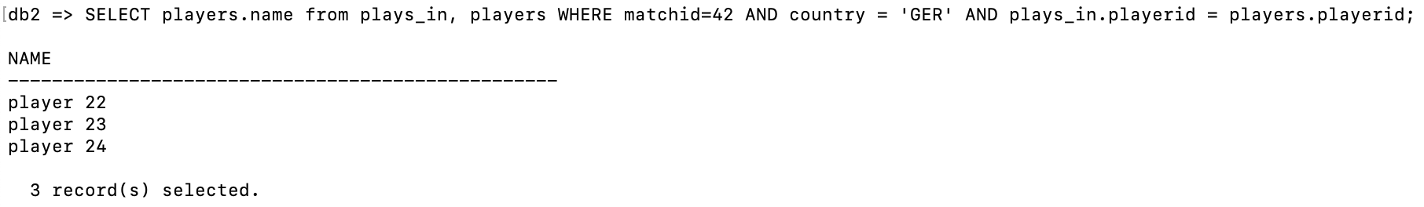

1. This menu item allows users to purchase a ticket. It shows the matches coming up in the next three days, the user picks a match then a ticket to view the price. The user can then purchase the ticket or not. If purchasing the ticket, the user must enter their email address (credit card info to be entered elsewhere-- out of scope). We update the tickets status to purchased, and insert a new tuple into the PURCHASED table. The user is then prompted to buy another ticket or return to the main menu.

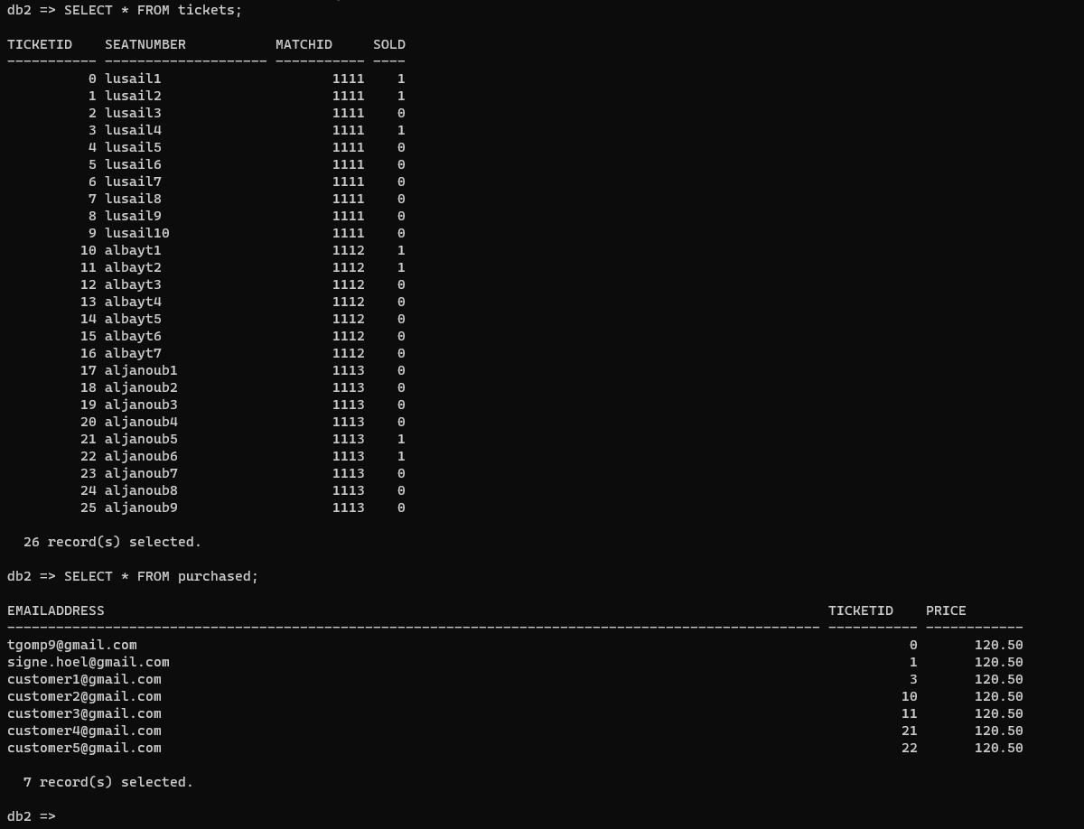

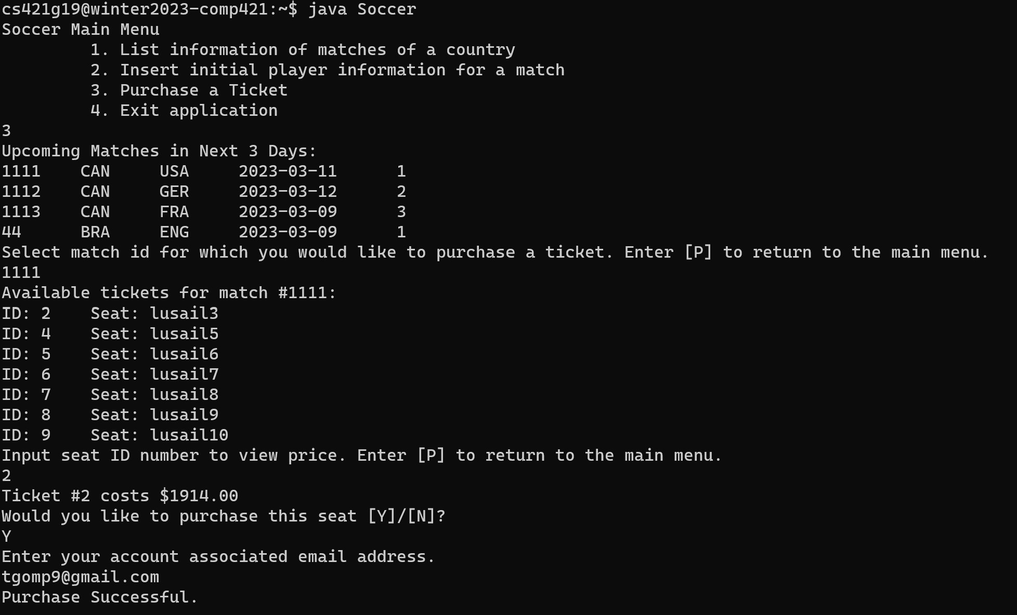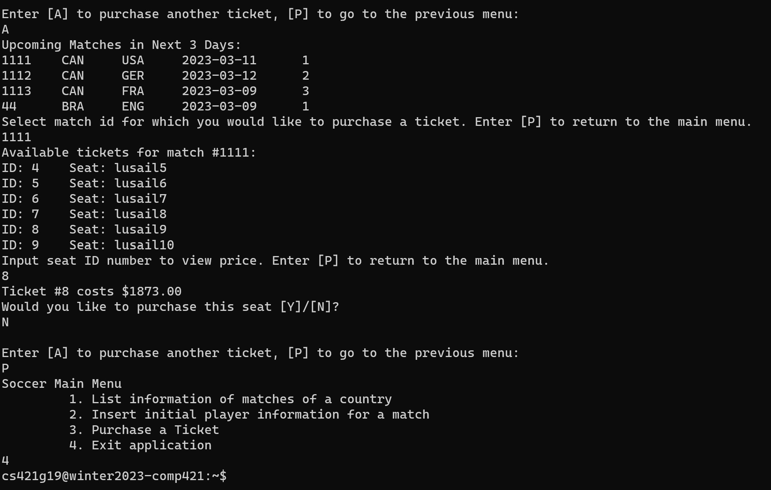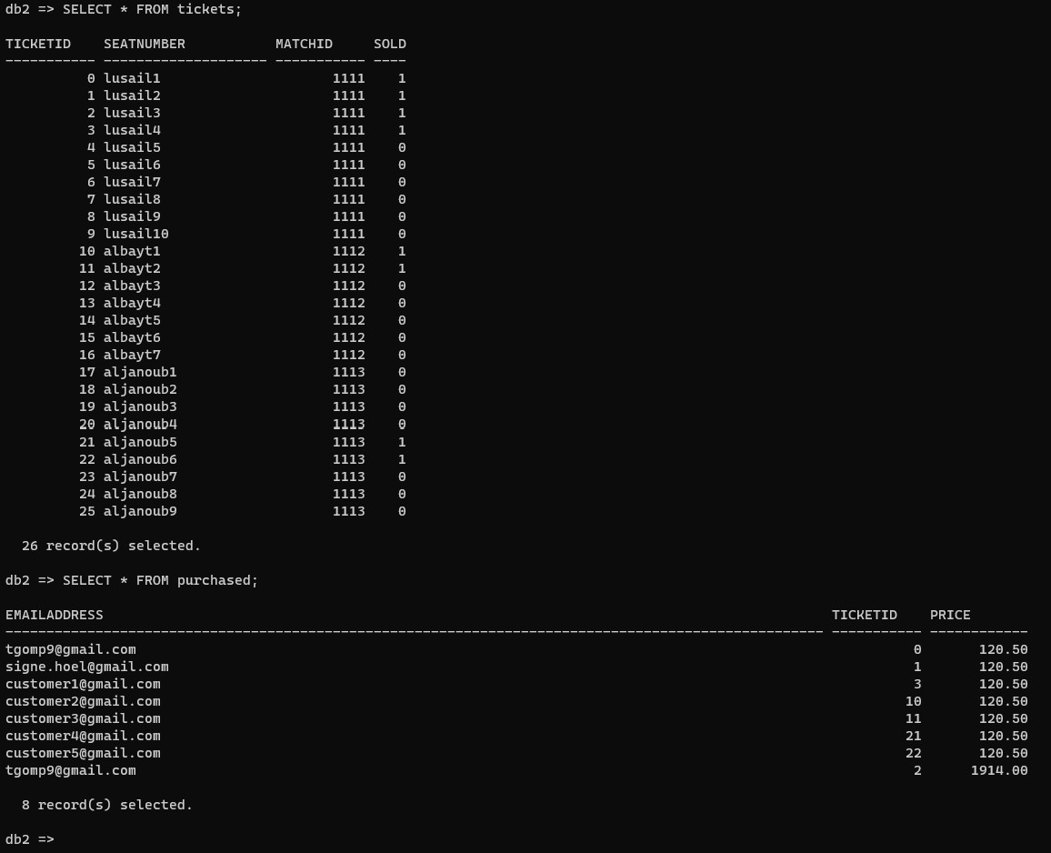

# Indexing

We chose an index over TICKETS using attributes matchid and sold so that when finding available tickets for a given match every ticket entry does not need to be checked. By using this index, tickets are already organized by match and no data page needs to be accessed to check if a ticket is sold or not.



# Data Analytics

**Note:** In our database, the group round is round = 1, round-of-16 is round = 2, quarterfinals is round = 3, etc.

**Query used to access top 5 scoring teams during the group round:**

SELECT * FROM

(SELECT t.country, count(*) as numgoals FROM matches m, goals g, teams t WHERE t.country = g.country AND m.round = 1 AND m.matchid = g.matchid GROUP BY t.country)

ORDER BY numgoals

FETCH FIRST 5 ROWS ONLY;

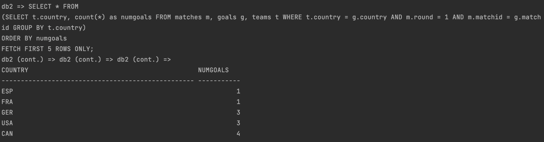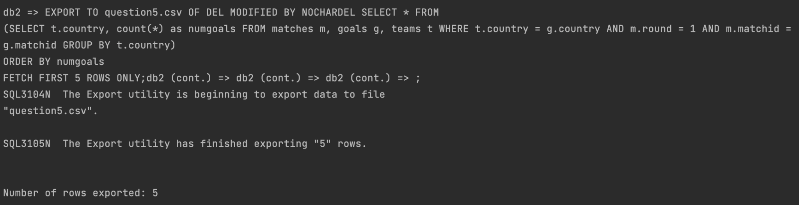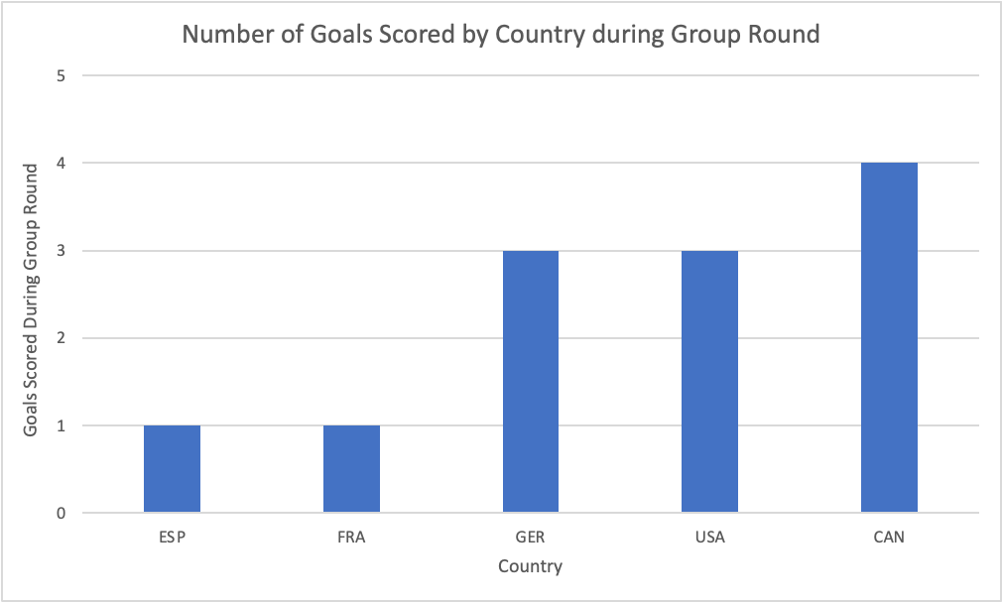

The excel workbook used to create this chart is named question5.xlsx.